Use Case Specification

DMT/RM01/TMP

|  |  |
| --- | --- |
| Project Code | PRJ_ RecruitmentManagementSystem_001 |
| Project Name | Recruitment Management System |

|  |  |  |
| --- | --- | --- |
| Prepared/Modified by | Role | Date of Preparation |
| Batch-4 |  | 02th june 2018 |
| Reviewed by | Role | Date of Review |
|  |  |  |
| Approved by | Role | Date of Approval |
|  |  |  |
| Circulation List |  | Version Number of the template:1.1 |
| Version Number | <version No > | 1.1 |

<<Customer>> REVIEW HISTORY

<<Customer comments on the Use case along with the signed off is tracked here>>

|  |  |  |  |  |  |  |
| --- | --- | --- | --- | --- | --- | --- |
| Version | 1.1 |  |  |  |  |  |
| Date |  |  |  |  |  |  |
| Reviewed by |  |  |  |  |  |  |
| Reviewed UI Specification doc |  |  |  |  |  |  |
| All Open Queries/issues closed |  |  |  |  |  |  |
| Agreement on Assumptions | A |  |  |  |  |  |
| Sign Off | <<Signature>> |  |  |  |  |  |

Disclaimer:

The scope of the project ‘Banking Exam Portal’ is restricted to the contents of this signed off use

]

TABLE OF CONTENTS

1. Use Case Name: Login to the RecruitmentManagementSystem……………………………………………… 4

2. Actor(s)………………………………………………………………………………………………………………. 4

3. Preconditions………………………………………………………………………………………………………... 4

4. Flow of Events………………………………………………………………………………………………………. 4

4.1 Basic Flow ………………………………………………………………………………………………………4

4.2 Alternative Flows …………………………………..…………………………………………………………4

4.2.1 Alternate Flow 1…………………………………..………………………………………………………… 5

4.2.2 Alternate Flow 2…………………………………..………………………………………………………… 5

4.2.2 Alternate Flow 3 …………………………………..…………………………………………………………….……5

Exception Flow 1: Userid is excedding the limit…………………………………..………………………………… 5

Exception Flow 2: Password is below the limit …………………………………..…………………………………......5

Exception Flow 3: Database Connectivity ………………………………………………………………………….6

Exception Flow 4: Network Failure …………………………………………………………………………………….6

5. Post Conditions………………………..…………………………………………………………….……………. 6

6. Special Requirements………………………..…………………………………………………………….……… 7

Performance ………………………..…………………………………………………………….………………………..7

Availability ………………………..…………………………………………………………….………………………..7

Security ………………………..…………………………………………………………….……………………......7

7. Extension Points ………………………..…………………………………………………………….……..7

< Business Rules ………………………..…………………………………………………………….………………7

9. Diagrams ………………………..…………………………………………………………….………………8

Use Case Diagram ………………………..…………………………………………………………….………………8

Success Scenarios ………………………..…………………………………………………………….………………9

Failure Scenarios ………………………..…………………………………………………………….……………....9

10. Issues ………………………..…………………………………………………………….……………………….9

11. UI Specifications ………………………..…………………………………………………………….…….9

12. Inter System Dependencies ………………………..…………………………………………………………9

13. Assumptions ………………………..…………………………………………………………….…………….10

1. Use Case Name: Functinalities Of Company Indivisual On Recruitment Management System

**Use Case ID:**  UC.User.Company_functionality_001

**Brief Description:** This Use Case describes the process by which the Comapany person as an indivisual Can Register Company Details, Post Job requirements and search for candidates based on Qualification, Position, Years of Experience.

1. Actor(s)

1. Companies (individuals on behalf of the company)

1. Preconditions

* Indivisual Person is an employee of a Company.
* Company Person has an access to the Recruitment Management Website
* Company Person has a valid user id and a password.

1. Flow of Events

4.1 Basic Flow

**Name:** Company Person login to Recruitment Management System and Search Candidates.

1. Company Person opens the browser and type the URL: [www.RMS.com](http://www.RMS.com) .
2. Company Person enters the login credentials and gets logged into the website.
3. Company Person clicks on Register Company Details button available on the home page
4. Company Person will be navigated to the Register Company Details page.
5. Company Person fills the details about Company.
6. Company Person Then Post the Job Requirements.
7. Company Person Then Search for the candidates based on Qualification, Position and Years of Experience .

Alternative Flows

Alternate Flow 1 (Company Person on home page to login)

1. Company Person is navigated to home page and is already logged into the website.
2. Company Person clicks on Register Company Details button available on the home page
3. Company Person will be navigated to the Register Company Details page.
4. Company Person fills the details about Company.
5. Company Person Then Post the Job Requirements.
6. Company Person Then Search for the candidates based on Qualification, Position and Years of Experience .

Alternate Flow 2(Company Person on Register Company Details page)

1. Company Person is redirected to Register Company Details page.
2. Company Person will be navigated to Register Company Details page.
3. Company Person fills the details about Company.
4. Company Person Then Post the Job Requirements.
5. Company Person Then Search for the candidates based on Qualification, Position and Years of Experience .

Exception Flow 1: Unsuccessful login

1. Company Person opens the browser and type the URL: [www.RMS.com](http://www.RMS.com)
2. Company Person enters user-id and password and clicks on the login button.
3. The system validates the user id and password combination with the database.
4. If the authentication is unsuccessful, a login failure message is displayed.

Exception Flow 2: HTTP session not created

1. Company Person is navigated to the home page
2. Company Person enters user-id and password and clicks on the login button.
3. The system validates the user id and password combination with the database.
4. On successful login, the admin home page is displayed.
5. On Successful login, the user-id and role fields are not stored in the HTTP session

Exception Flow 3 Company Person mismatches the Company details

1. Company Person opens the browser and type the URL: [www.RMS.com](http://www.RMS.com) .
2. Company Person enters the login credentials and gets logged into the website.
3. Company Person clicks on Register Company Details button available on the home page
4. Company Person will be navigated to the Register Company Details page.
5. Company Person fills the details about Company.
6. Company Person Then Post the Job Requirements.
7. Company Person Then Search for the candidates based on Qualification, Position and Years of Experience .

.

Exception Flow 4: Database Connectivity

1. Company Person visits the Recruitment Management System URL [www.RMS.com/exam](http://www.RMS.com/exam) using any standard browser.
2. Company Person enters user-id and password and clicks on the login button.
3. The system validates the user id and password combination with the database.
4. System displays error message regarding database connectivity.

Exception Flow 5: Network Failure

1. Company Person visits the Recruitment Management System URL [www.RMS.com](http://www.RMS.com) using any standard browser.
2. The system displays error message regaring network failure.
3. Post Conditions

| Flow Name | Post Condition |
| --- | --- |
| Company Person login to Recruitment Management System and Search Candidates | Company Person Gets a list of Eligible Candidates. |
| Company Person on home page to login | Company Person Gets a list of Eligible Candidates. |
| Company Person on Register Company Details page | Company Person Gets a list of Eligible Candidates. |
| Unsuccessful login | A login failure message is displayed. |
| HTTP session not created | the user-id and role fields are not stored in the HTTP session |
| Company Person mismatches the Companytdetails | Company Person has updated the mismatched details. |
| Database Connectivity | The website should display error message for Database connectivity |
| Network failure | The website should display error message for Network failure |

1. Special Requirements
2. Performance

* On kiosks operating with a PSTN connection, users shall have greater than 50Kbps connection speed.
* Website should responce within 6 sec. for all the request by the user.

1. Availability

* Website should be available for 24*7 to Adminstrator.

1. Security

* On Each page in the Register Company Details page checks for a valid user login by checking the value of a session variable.

User Interface

* 1. The letters on Menus shall be bold
  2. The active links shoul be displayed in red color
  3. The visisted links should be displayed in purpule color
  4. The Unvisited links should be displayed in blue
  5. The logout and back button should be available on every page of the Website
  6. Look and feel and color of application should be proper.
  7. In case of Field level validation error messages should be displayed in red color.

1. Extension Points
2. Extension in Alternate Flow 1:

* If the Company Person has entered wrong user credentials .
* The system prompts the user to re-enter the credentials
* Company Person enters the username and password
* The system validates the Company Person user id and password combination with the database.
* On successful login, the Company home page is displayed.

Extension in Basic Flow :

In step 5 , if the administrator has entered wrong placement details.

1. If administrator is entered the wrong details in how many individuals were placed in a particular month.
2. Administrator is redirected to the step 5 of the basic flow.
3. Administrator re-enters the valid value in how many individuals were placed in a particular month field.

< Business Rules

| Business Rule Name | Business Rule Description | System action (if BR fails) |
| --- | --- | --- |
| BR01 | Company Person should be valid | User got popup to reenter the credentials. |
| BR02 | Admin And Applicants should be able to view the details added by the company Person. | Display notification message “ details not available” |
| BR03 | Applicant should not be able to update or delete the company Details added by the company Person. | Display message “ You Cannot Make any Changes On This authentication is needed” |

1. Diagrams

Use Case Diagram

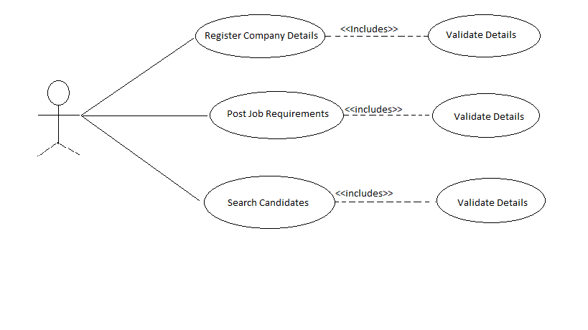

Success Scenarios

* Successful Company Person login
* Successful Updating details of Company in the portal.
* Successfully HTTP session got created

Failure Scenarios

* Company Person login authentication fails
* HTTP session not created
* Company Person not able to update the company details in portal.

1. Issues

* What if the HTTP session not created.
* What if the user is able to access the page of the application by simply entering the URL of that

page on the address bar of the browser.

1. UI Specifications

<https://www.RMS.com>

1. Inter System Dependencies

Module: Company

**Use case name**: Functionality of company indivisual on Recruitment management System Application.

**Impact**: If Company Person has not added or updated Company details the applicant will not be able to see the details and will not be able to apply for jobs.

1. Assumptions

* Application is valid and up running
* Application is launcing in all the browser
* Company Person should have valid username and password

( more e.g

1. The Company person should be authenticate.
2. Company person should know the valid URL of Recruitment Management System.
3. Company person should have Google chrome browser for best view of site.)

REVISION HISTORY OF THE WORK PRODUCT

<to be maintained by projects>

|  |  |  |  |  |  |
| --- | --- | --- | --- | --- | --- |
| # | Date | Version # | Section Changed | Details of changes made | Approved By |
| 1 |  |  |  |  |  |
| 2 |  |  |  |  |  |